ROSSLARE AC-Q41H Anti-Vandal PIN Standalone Controller
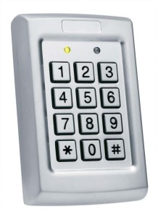
This advanced anti-vandal 500 user standalone controller features metal keys for PIN code user credentials. AC-Q41H has a rugged metal body ideal for installation in high traffic environments. This model comes with removable terminal blocks, allowing quick installation, and utilizes advanced programming options.
- 500 PIN users
- Smooth attractive design, with anti-vandal construction
- 3 operational Security Levels can be selected with special PIN codes
- Supports up to 8-digit PIN codes, with timed wrong code lockout after several wrong attempts
- 2 tri-colored LEDs and integral sounder for programming and operational indications
- Removable terminal blocks for unit wiring

PROFESSIONAL GRADE FEATURES
- Optical tamper detection.
- Automatic internal heater prevents key freeze at -20°C (4°F)
- 10 programmable modes for auxiliary input and output (2 Amp Form C Relay)
- 2 Amp Form C Lock Strike Relay, for fail-safe and fail-secure, with input for REX
- Supports: Door Ajar, Forced, Shunt, Monitor, and Secure mode
- Door bell key feature operation (from ‘*’ bell key), with Rosslare’s accessory BL-D40

