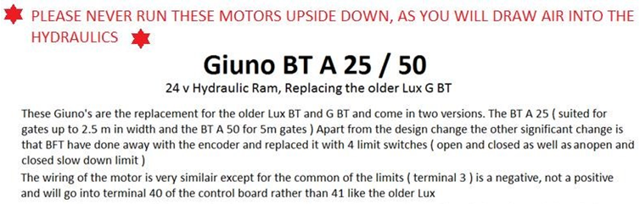
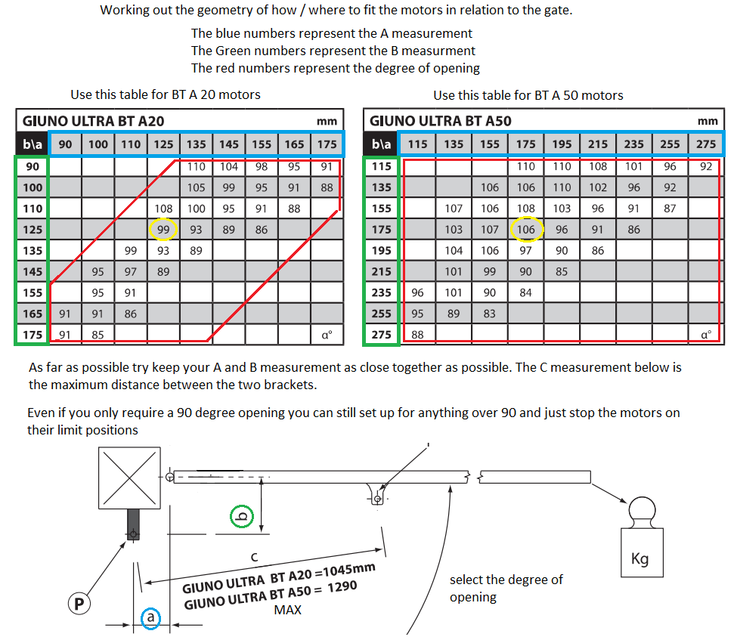

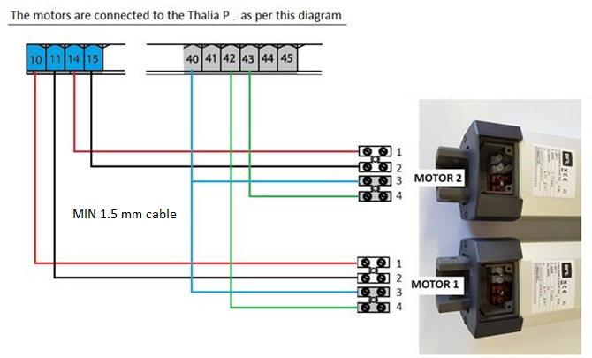
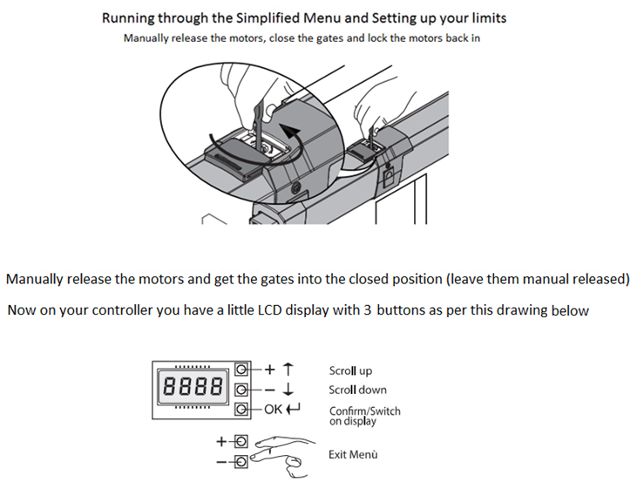

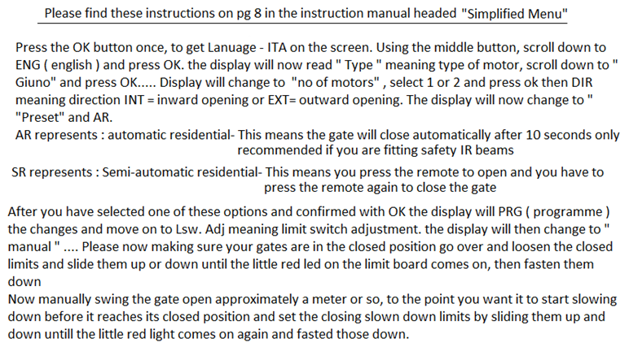

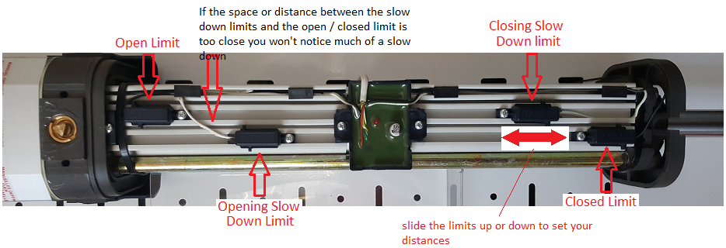
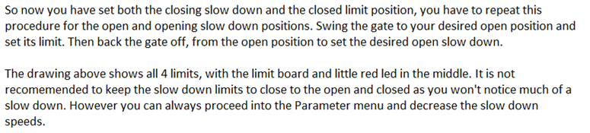
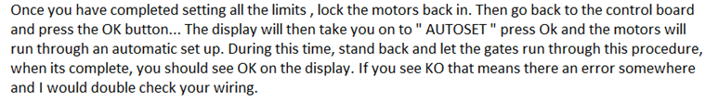
Programming the remote controls
After the Auto set procedure the display should read OK, if you press Ok button it will then change to “ Remotes and “ Hidden Button “ Now press the two buttons on the remotes at the same time and the display will read “ Release “ and then “ Desired Button” where you can press the desired button on your remote. The display should then read OK 01 and you can repeat the procedure for the remaining remotes

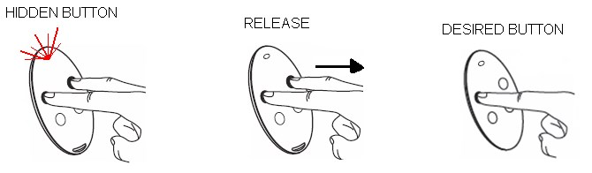

IR SAFETY BEAM SET UP
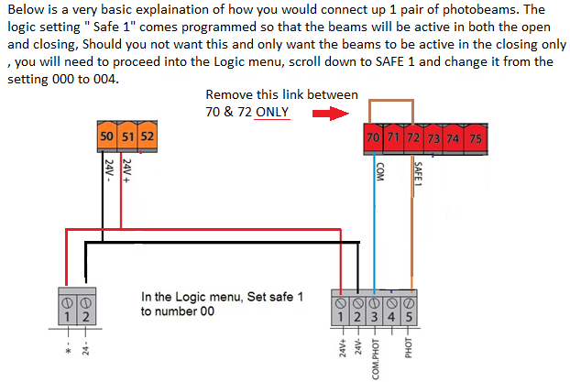
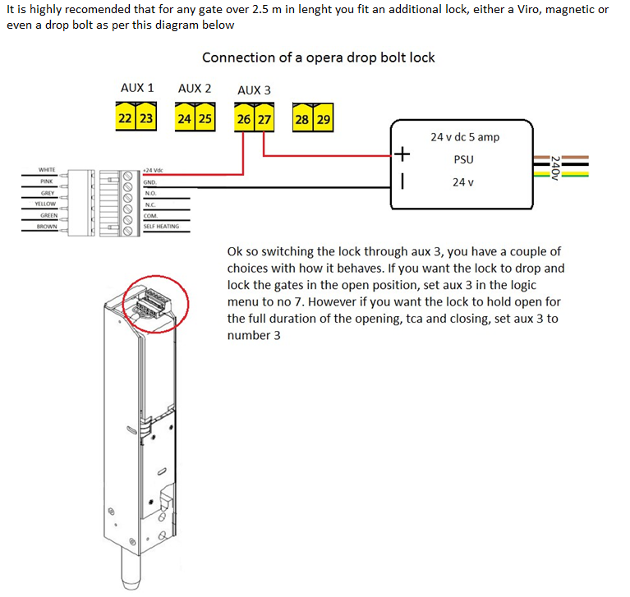

PLEASE REMEMBER THAT THIS IS JUST A QUICK REFERNCE GUIDE, DESIGNED TO HELP, BUT NOT A SUBSTITUTE FOR READING THE FULL INSTRUCTION MANUAL

